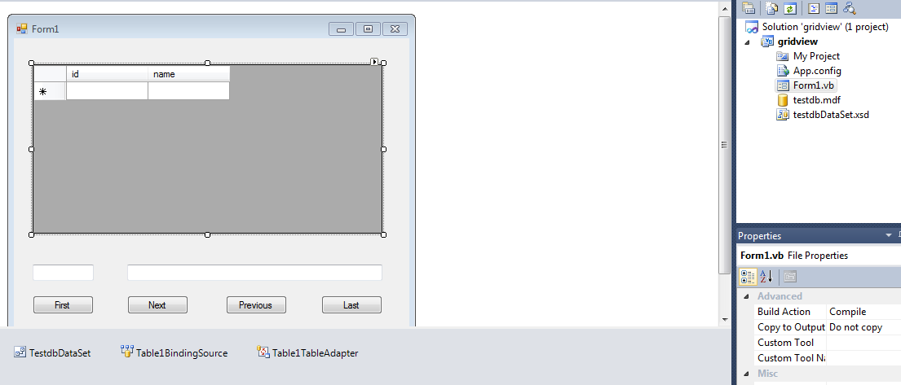

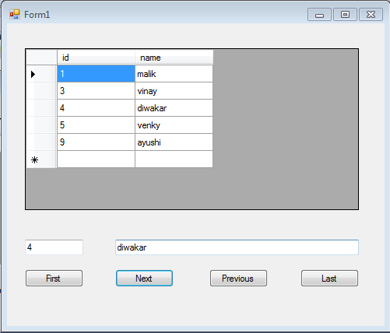

Public Class Form1

Dim i As Integer

Private Sub Form1_Load(ByVal sender As System.Object, ByVal e As System.EventArgs) Handles MyBase.Load

'TODO: This line of code loads data into the 'TestdbDataSet.Table1' table. You can move, or remove it, as needed.

Me.Table1TableAdapter.Fill(Me.TestdbDataSet.Table1)

End Sub

Private Sub btnFirst_Click(ByVal sender As System.Object, ByVal e As System.EventArgs) Handles btnFirst.Click

If (TestdbDataSet.Tables(0).Rows.Count > 0) Then

i = 0

txtID.Text = TestdbDataSet.Tables(0).Rows(i)("id").ToString()

txtName.Text = TestdbDataSet.Tables(0).Rows(i)("name").ToString()

End If

End Sub

Private Sub btnNext_Click(ByVal sender As System.Object, ByVal e As System.EventArgs) Handles btnNext.Click

If (i < TestdbDataSet.Tables(0).Rows.Count - 1) Then

i += 1

txtID.Text = TestdbDataSet.Tables(0).Rows(i)("ID").ToString()

txtName.Text = TestdbDataSet.Tables(0).Rows(i)("Name").ToString()

Else

MsgBox("You are on last record")

End If

End Sub

Private Sub btnLast_Click(ByVal sender As System.Object, ByVal e As System.EventArgs) Handles btnLast.Click

i = TestdbDataSet.Tables(0).Rows.Count - 1

txtID.Text = TestdbDataSet.Tables(0).Rows(i)("ID").ToString()

txtName.Text = TestdbDataSet.Tables(0).Rows(i)("Name").ToString()

End Sub

Private Sub btnPrevious_Click(ByVal sender As System.Object, ByVal e As System.EventArgs) Handles btnPrevious.Click

If (i = TestdbDataSet.Tables(0).Rows.Count - 1 Or i <> 0) Then

i -= 1

txtID.Text = TestdbDataSet.Tables(0).Rows(i)("ID").ToString()

txtName.Text = TestdbDataSet.Tables(0).Rows(i)("Name").ToString()

Else

MsgBox("You are on first record")

End If

End Sub

End Class

